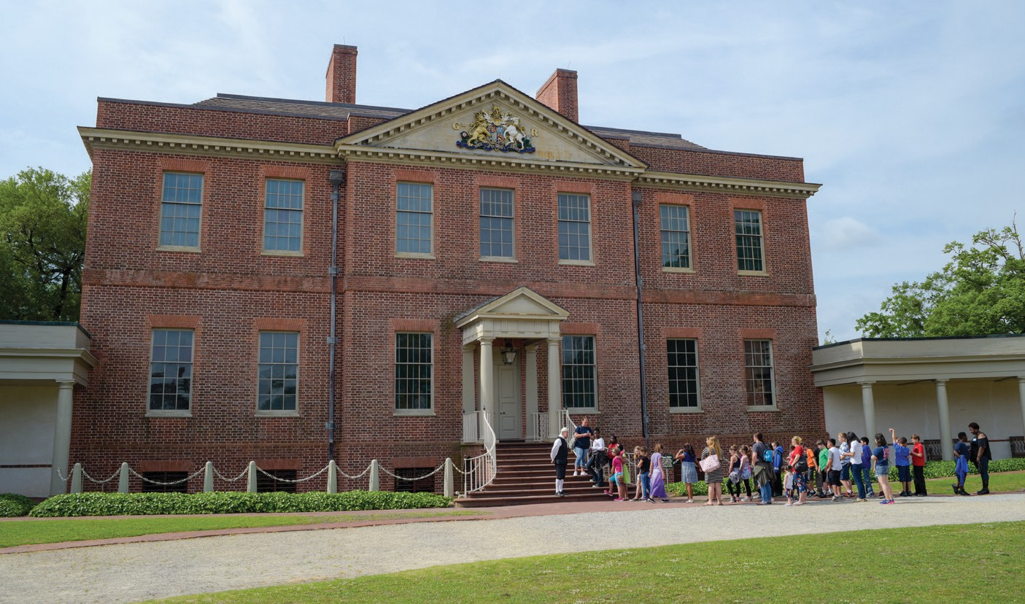

What is Palace Scholars?
The Palace Scholars Awards Program provides Title I schools with opportunities to experience history in person at Tryon Palace by offering financial awards that offset field trip
expenses. The Palace Scholars Awards Program is an initiative of the Tryon Palace Foundation and is fully funded by contributions from generous donors who share Tryon Palace’s goal of ensuring that all students have access to multidisciplinary programs that supplement traditional curriculum.

Please Provide the Following Information
Teacher Name
School Name
District/County
Phone Number
Email Address

Please Provide Information Regarding Your 2025/2026 School Year Funding Request:
Grade Level: Number of Students: Number of Teachers: Total Funding Requested:
Requested Expenses (If not needed, please note N/A)
Substitute Teachers: $ Number of Buses:
No. Bus Drivers: Est. Cost: $ No. of Roundtrip Miles: Est. Cost: $
(Maximum $16/hr will be reimbursed.) (Mileage is reimbursed up to $3.00 per mile.)

Award Maximum $2000



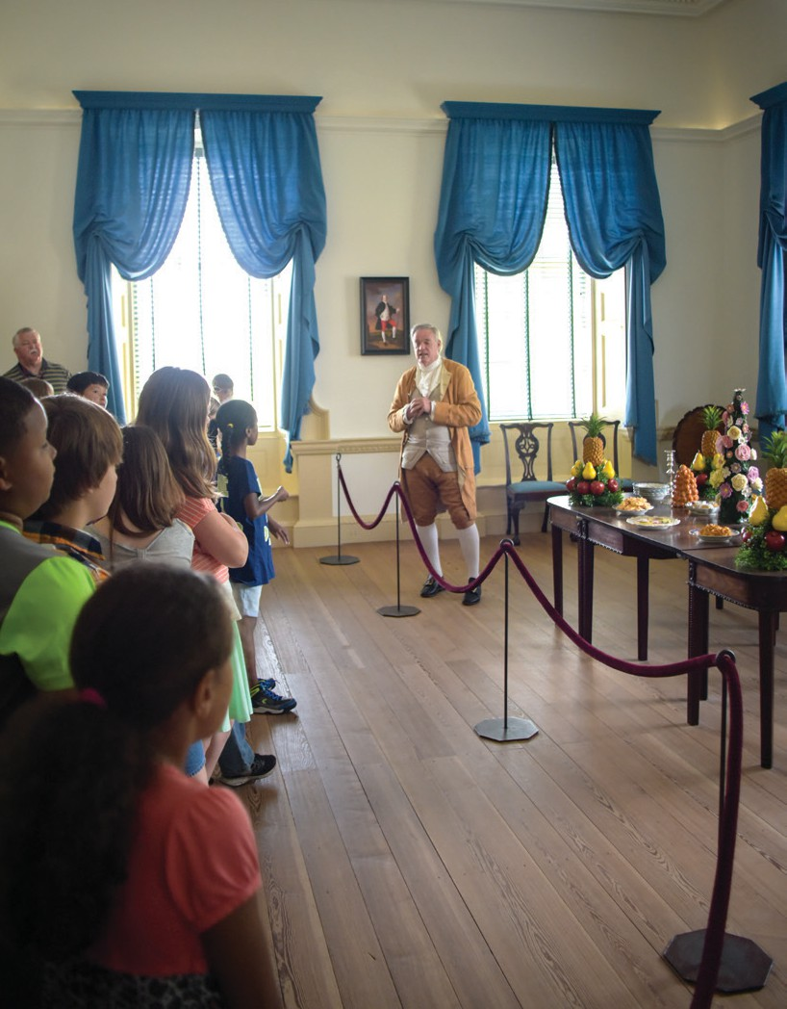
Tryon Palace invites all Title I school educators in North Carolina to apply for a field trip award. Awards reimburse transportation and substitute teacher fees up to
$2000 for the 2025-2026 School Year. Applications open on August 1, and funding decisions are made monthly throughout the academic year. Schools will be notified within 45 days or sooner of application receipt.

Awards are based on actual invoices submitted by the school following the field trip:
- Substitute Teachers
- Roundtrip Bus Mileage: Up to $3.00 per mile
- Additional Transportation Amounts Paid (If applicable.):
  - 100 to 250 miles: Extra $100
  - Over 250 miles: Extra $200
- Bus Driver Expenses: Maximum $16 per hour

Step 1
Please complete the front of this application with your contact information, number of students, and requested financial support.

Step 2
Secure a letter from your school principal noting your status as a Title 1 school.

Step 3
Please provide answers to the following questions on a separate page.
How will a field trip to Tryon Palace enhance learning in your classroom?
How will students in your classroom specifically benefit from a field trip to Tryon Palace?


Step 4
Please submit your application, Title I letter, and answers to questions by email to:
PalaceScholars@TryonPalace.org

Please call (252) 639-3516 for questions or directions to submit by fax or mail.

